Daniel
- Pyrate Captain
- Member

- 652 posts
- Gender:Male
- Location:McLean, VA
- Interests:History, pirates, fiction, writing, writing historical fiction about pirates, jokes, games, law.
Posted April 4, 2010 · Report post
If you want to rob a ship (which you, being a pirate, would like to do) you have to get onto it first. In some cases, the persons who are already on that ship are violently disinclined to allow you on board. So how do you do manage to get aboard anyway? My sources say remarkably little about the nitty-gritty of getting from your own ship into somebody else's.
Boarding from a boat
One thing that looks pretty clear: pirates' favorite way to get on board the target ship was with the active help and cooperation of that ship's crew. The usual drill was to tell the other ship's captain to lower a boat and come aboard the pirates' ship, with appropriate threats, curses, and shooting across the bow to convince said captain that rapid compliance would be good for his health. With the captain in their power, the pirates would persuade him to order his crew to allow them aboard, and a prize or pillaging crew would be dispatched, perhaps in the same boat that brought the captain, and would be grudgingly helped aboard by their intended victims.
But taking the captain hostage first was optional. At least two of Stede Bonnet's victims allowed the pirates to board, despite strongly suspecting who they were, and surrendered readily the minute the boarders put their hands on their cutlasses. There may have been no more than two or three boarders, but the mere threat of the Royal James lurking in the twilight dissuaded the captains from resisting.
Even in these cases, the actual means of getting from boat to ship is a little vague. Rope ladder? Boatswain's chair? Fixed boarding stairs? Grappling line? Presumably only very small ships had low enough freeboard that a man in a boat could have reached the target ship's gunwale standing up. Some buccaneering accounts suggest that the target ship's stern offered handholds enough to climb aboard. If boarding from the side, it may have been possible for men in a boat to reach the chains, pull themselves onto the channels, and climb up the shrouds from there. One of Stede Bonnet's victims mentions that the pirates grasped their cutlasses "as soon as they came up the shrouds," which suggests they did indeed use this route.
Boarding from ship to ship
I've never seen any source saying that pirates ever really swung from one ship to another on a line hooked in the yards in Errol Flynn/Jack Sparrow style. Nor have I seen any primary source that bears out the idea, often reported in secondary sources, that pirates fashioned stair steps out of boarding axes driven into the prize's hull. May we safely consider these two methods fictional?
Benerson Little reports one case where privateers leaped from their own deck to the prey's. This was dangerous; one man fell between the ships and was crushed between them, splattering his brains onto his comrade Duguay-Trouin. This may have been the most common method, but obviously there were situations where it couldn't have worked. First, the pirates would have needed a freeboard nearly as high as their opponent's; they couldn't have jumped onto a ship more than two or three feet higher than their own, except by grabbing the gunwale with their hands at the end of the leap and pulling themselves on board. Besides risking the fate of Duguay-Trouin's friend, this would have left the pirates' hands on a ready-made chopping block for anyone with a cutlass. Given the many cases where pirates in sloops or even smaller craft attacked large merchantmen, the freeboard problem must have been common.
Furthermore, even when two ships had equal freeboard, the distance from gunwale to gunwale would often have been too far to jump. Because of tumble-home, two ships touching each other at the waterline might be as much as ten feet apart at the gunwales. Few pirates could have jumped such a distance. Swinging aboard would have solved this problem, as would laying down gangplanks from ship to ship. Running grappling lines from the prey's rigging to the pirates' capstan and tightening until the two ships' gunwales touched each other seems impractical. But what method did pirates actually use when they couldn't jump directly to the other guy's deck?

Mission
- Goat Specialist
- Admin

- 5,081 posts
- Gender:Male
- Location:Monroe, MI
- Interests:Scholarly piracy, designing and creating haunted house rooms and props, movies, abstract thinking, abstruse thinking, obstructive thinking, ideating, random thinking, movies, cartoons, movies, movies scores, cycling, world peace and small furry dogs, movies, writing, drawing, personal skills training, gremlins and, of course, lest I forget, movies.
Posted April 4, 2010 · Report post
Actually, as I recall it, what Little has to say on positioning the pirate vessel in relationship to the wind and the ship to be boarded probably had more to do with successful boarding than the actual mechanics of the thing. Once your prey was secured from escaping it would seem to me that the mechanics of getting aboard would have more to do with common sense than anything.

Fox
- Old Twillian
- Moderator

- 2,564 posts
- Gender:Male
- Location:Beautiful lush Devon, England
- Interests:Nautical history of the 16-18th centuries and living history based thereon.
Shooting pirates.
Posted April 4, 2010 · Report post
Quote
Presumably only very small ships had low enough freeboard that a man in a boat could have reached the target ship's gunwale standing up.
I think you should probably reverse this statement. Only very large ships would have a freeboard too high to clamber up. Nonetheless, coming up the chains and shrouds is probably the easiest route. This is my boat alongside the Golden Hind, a 120 ton ship.
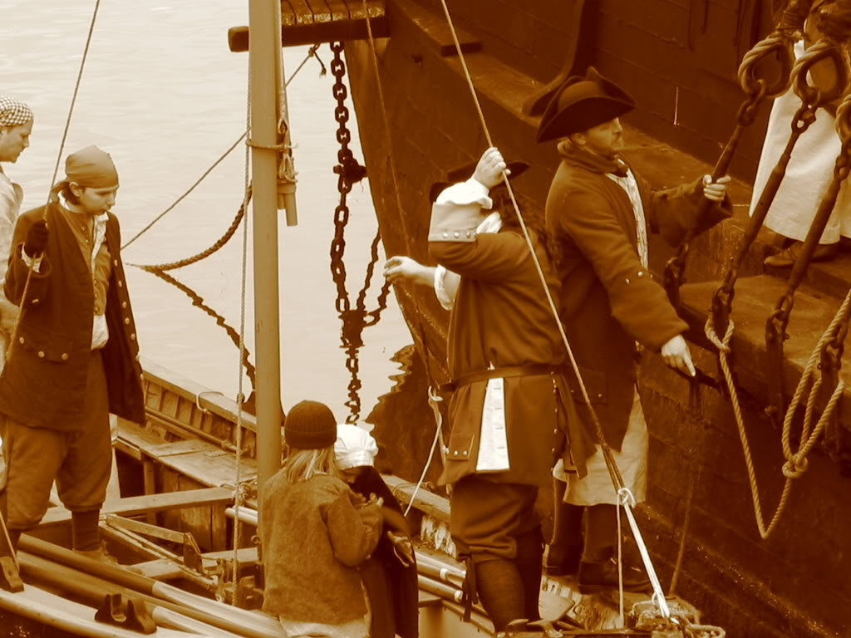

Daniel
- Pyrate Captain
- Member

- 652 posts
- Gender:Male
- Location:McLean, VA
- Interests:History, pirates, fiction, writing, writing historical fiction about pirates, jokes, games, law.
Posted April 4, 2010 · Report post
Very informative picture. So you can actually stand on the boat's gunwale without tipping it! I did not realize that. And that gunwale gives you a good two feet of extra height.
Another thing I didn't realize; there's a sort of "step" built into the side of the Golden Hind, at the base of the bulwark. Was that a common design feature? It certainly would have made boarding a lot easier. I assume the step is there because it's more important to be able to recover boat crews safely than to make it tough for hostile boarding parties to get onto the ship?

callenish gunner
- Scourge o' the 7 Seas
- Member

- 2,138 posts
- Gender:Male
- Location:Pennsylvania mountains north of Clarion
- Interests:The Callenish gunner has just hoved into view looking for safe anchorage in these waters... purveyor of bladed and flintlock weaponry also leather accessories ..........painter of portraits and period scenes by avocation I'm getting my armoury business underway and will be doing as many festivals as I can ...right now along the east coast or great lakes
Posted April 4, 2010 · Report post
Many ships also had ladders built into their sides. There were also grappling hooks that would bring the ships side by side and using ropes off the yards would not have been impossible or once grappled they could use long planks between ships

Fox
- Old Twillian
- Moderator

- 2,564 posts
- Gender:Male
- Location:Beautiful lush Devon, England
- Interests:Nautical history of the 16-18th centuries and living history based thereon.
Shooting pirates.
Posted April 4, 2010 · Report post
On 4/4/2010 at 2:56 PM, Daniel said:
Very informative picture. So you can actually stand on the boat's gunwale without tipping it! I did not realize that. And that gunwale gives you a good two feet of extra height.
Depends on the size of boat and how much weight is already in it. That longboat is 27' long and 7' in the beam, with about half a ton of ballast. I wouldn't stand on the gunwale of an empty dinghy!
Quote
Another thing I didn't realize; there's a sort of "step" built into the side of the Golden Hind, at the base of the bulwark. Was that a common design feature?...
Um, it's not uncommon - but it depends a lot on the size and type of vessel. I don't honestly know if it has a specific purpose. I doubt you'd see such a feature on the kind of merchantman likely to be attacked in the Caribbean. (Random, unprovenanced thought: it may be to do with the mounting of guns, since even until quite late guns were often loaded 'outboard').

MarkG
- Pyrate Captain
- Member

- 587 posts
- Location:Ohio
Posted April 4, 2010 (edited) · Report post
On 4/4/2010 at 2:56 PM, Daniel said:
Very informative picture. So you can actually stand on the boat's gunwale without tipping it! I did not realize that. And that gunwale gives you a good two feet of extra height.
Another thing I didn't realize; there's a sort of "step" built into the side of the Golden Hind, at the base of the bulwark. Was that a common design feature? It certainly would have made boarding a lot easier. I assume the step is there because it's more important to be able to recover boat crews safely than to make it tough for hostile boarding parties to get onto the ship?
The "step" is part of most large sailing ships. The mast is held in place on either side by shrouds (these are what sailors climb using horizontal ratlines). It order to get a better angle and reduce the strain on the shrouds, the are attached to the hull with a small platform to push them out further. On many ships this makes an easy way to climb on. On the Mayflower, that is how you get on and off of the longboat or the Shallop.
You can see the same feature on the kalmar nyckel. It also has a built-in ladder.
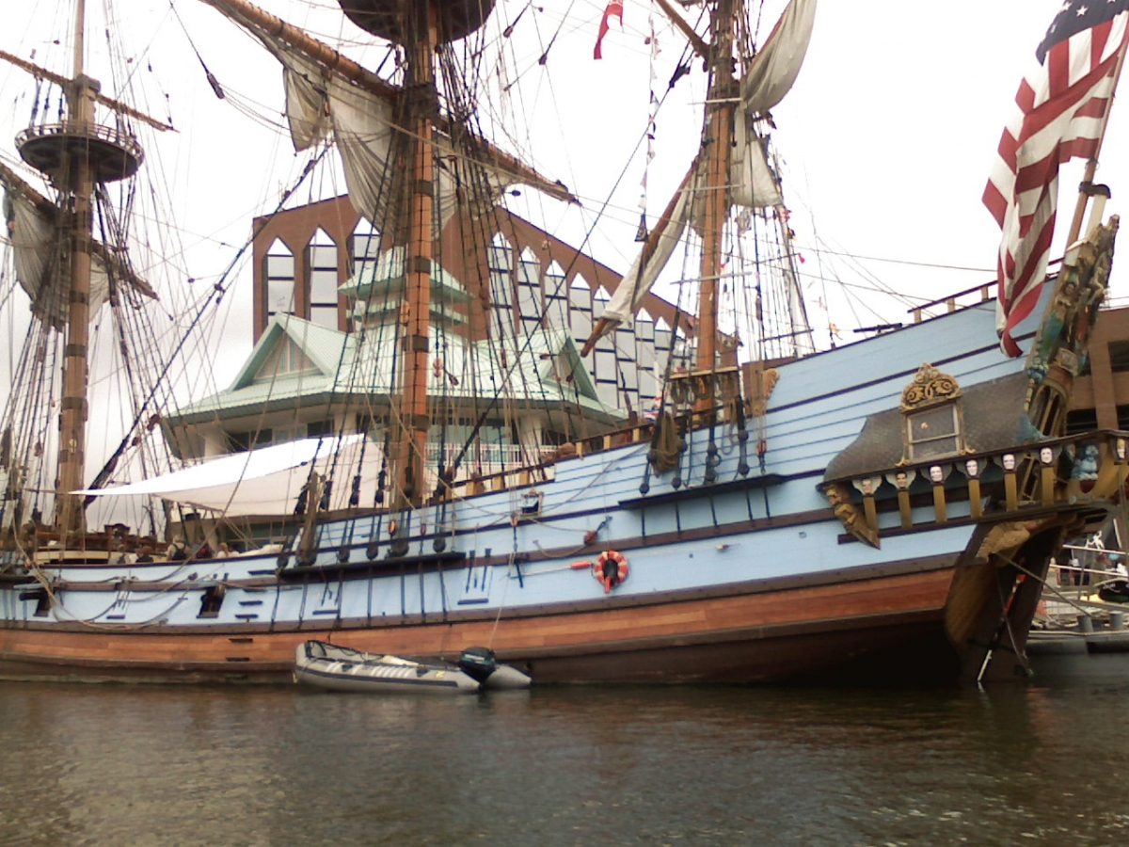
Mark
Edited April 4, 2010 by MarkG

Daniel
- Pyrate Captain
- Member

- 652 posts
- Gender:Male
- Location:McLean, VA
- Interests:History, pirates, fiction, writing, writing historical fiction about pirates, jokes, games, law.
Posted April 4, 2010 · Report post
On 4/4/2010 at 9:52 PM, MarkG said:
The "step" is part of most large sailing ships. The mast is held in place on either side by shrouds (these are what sailors climb using horizontal ratlines). It order to get a better angle and reduce the strain on the shrouds, the are attached to the hull with a small platform to push them out further.
I think we're talking about two different things. The platform that pushes the shrouds and chains out further is called the channel. In Foxe's picture, they're getting ready to climb onto the channel. But in Foxe's picture you can also see a step on the side of the ship, just a couple of inches higher and inboard from the channel, that runs all along the side of the ship; you can see one crewman's leg standing on it. The same step can be seen in this picture: the lower fluke of the anchor points right to it. The step could be easily reached from a boat, although I sure as hell wouldn't want to try it in a heavy sea.
I'm not sure if there is such a step in your picture of the Kalmar Nyckel, although maybe those long brown-painted strakes on the sides project out far enough to step on; it's hard to see from this angle.
I can see the fixed ladder on the Kalmar Nyckel, just between the aftermost gunport and the main chains.

MarkG
- Pyrate Captain
- Member

- 587 posts
- Location:Ohio
Posted April 5, 2010 · Report post
On 4/4/2010 at 11:01 PM, Daniel said:
On 4/4/2010 at 9:52 PM, MarkG said:
The "step" is part of most large sailing ships. The mast is held in place on either side by shrouds (these are what sailors climb using horizontal ratlines). It order to get a better angle and reduce the strain on the shrouds, the are attached to the hull with a small platform to push them out further.
I think we're talking about two different things. The platform that pushes the shrouds and chains out further is called the channel. In Foxe's picture, they're getting ready to climb onto the channel. But in Foxe's picture you can also see a step on the side of the ship, just a couple of inches higher and inboard from the channel, that runs all along the side of the ship; you can see one crewman's leg standing on it. The same step can be seen in this picture: the lower fluke of the anchor points right to it. The step could be easily reached from a boat, although I sure as hell wouldn't want to try it in a heavy sea.
I'm not sure if there is such a step in your picture of the Kalmar Nyckel, although maybe those long brown-painted strakes on the sides project out far enough to step on; it's hard to see from this angle.
I can see the fixed ladder on the Kalmar Nyckel, just between the aftermost gunport and the main chains.
I'm guessing that that "platform" is the main deck extending past the rail. It's in the right place and I can't think of any other reason for it. I can see it being done that way to strengthen the deck and the rail. I'm familiar with most of the 16th and 17th century ships in America and I've climbed over some of them. I've never seen this feature on any of the others. I don't know how common it would have been in period.
Mark

Gentleman of Fortune
- Dread Pyrate
- Member

- 1,456 posts
- Gender:Male
- Location:Germany... Franconia (northern Bavaria)
- Interests:I *used* to be an environmental scientist, until I married a DoDDs teacher in 1997. Since then, I have been living in, and traveling around, Europe (First the UK, now Germany).
My hobbies are all the "usual suspects" for those interested in re-enacting and Golden Age of Piracy stuff.... but I have drifted away from the pirate scene as my location and young family don't allow for any more than "virtual" pirate participation. Besides Piracy, I am into Reverend Guitars and Vintage Corvettes.
Posted May 5, 2010 · Report post
The other thing to consider is, in General, we are talking a smaller FASTER pirate ship against a larger SLOWER Commercial Vessel.
So the speed and maneuverability edge is in the pirates favor.
Next is numbers. A pirate ship would have 40, 60, 120 men or more on board... the "Victim" would probably have just enough men to sail her... 12, 20, 32?
So the scenario is that a Smaller Faster Ship with a crew that outnumbers you 4 or 5 to one says, "Stop where you are or we will catch you and kill everyone of you"
Your average sailor on the commercial vessel really doesn't have a dog in the fight... its not his ship or his cargo.... so, you can have it.

Fox
- Old Twillian
- Moderator

- 2,564 posts
- Gender:Male
- Location:Beautiful lush Devon, England
- Interests:Nautical history of the 16-18th centuries and living history based thereon.
Shooting pirates.
Posted May 5, 2010 (edited) · Report post
I'm glad this topic has been bumped, because I can't resist posting this video of last weekend...
Edited May 5, 2010 by Foxe

Bos'n Cross
- Pyrate Captain
- Member

- 536 posts
- Gender:Male
- Location:Portsmouth
- Interests:many things.......
Posted May 5, 2010 · Report post
.........damn you mr foxe.......having a good time....... real ships...*grumble grumble......real accents......damn you.......

Capt. Sterling
- Sticky Fingers Sterling Needs a New Hat
- Member

- 10,302 posts
- Gender:Pyrate Hunter
- Location:here
- Interests:Killing pirates, haven't met one yet worth keeping alive....
Posted May 5, 2010 · Report post
Wait and you want to come here and play... how bout we switch things around a bit?

michaelsbagley
- Smells Like Wet Sheep
- 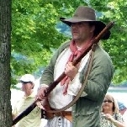
- Moderator

- 2,548 posts
- Gender:Male
- Location:Columbus, Ohio
- Interests:Mostly into GAoP, but starting to develop more Buccaneer era stuff for re-enacting as well. Generally I do re-enact both piratical/nautical and other impressions from the period. I am focusing on more "common" impressions from the period (i.e. average sailor/pirate, rank and file Red Coat, early Colonial huntsman, etc.)
Posted May 5, 2010 · Report post
On 5/5/2010 at 0:37 PM, Cross said:
.........damn you mr foxe.......having a good time....... real ships...*grumble grumble......real accents......damn you.......
Well Cross, one might have to live overseas for the real accent... But one doesn't need to live in the UK to attend a pirate event with a boarding action. We did one back in September(not nearly as good as Foxe's), and will be doing it again in a week and a half (with improvements over September, but still not likely as good as the one in Foxe's video). Maybe if we're lucky someone will have a video camera there and we can post that in a few weeks.
Mark G and I completed the second rope ladder this past Sunday so we can have more than one person going over the rail at a time.

Fox
- Old Twillian
- Moderator

- 2,564 posts
- Gender:Male
- Location:Beautiful lush Devon, England
- Interests:Nautical history of the 16-18th centuries and living history based thereon.
Shooting pirates.
Posted May 5, 2010 · Report post
I am reliably informed that planning for next year's event is already in hand. Any of you colonials who wish to come and play would be most welcome to do so. Next year I want four boats attacking instead of one and a whole heap more people...

Tartan Jack
- Notorious Pyrate
- 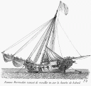
- Member

- 908 posts
- Location:South Carolina
- Interests:History, Scotland, Batman, Cars, and more<br />Married with 2 kids<br />
Posted May 5, 2010 · Report post
On 5/5/2010 at 1:24 PM, Foxe said:
I am reliably informed that planning for next year's event is already in hand. Any of you colonials who wish to come and play would be most welcome to do so. Next year I want four boats attacking instead of one and a whole heap more people...
Help me pay for the flight and I'll be there!

Capt. Sterling
- Sticky Fingers Sterling Needs a New Hat
- Member

- 10,302 posts
- Gender:Pyrate Hunter
- Location:here
- Interests:Killing pirates, haven't met one yet worth keeping alive....
Posted May 5, 2010 · Report post
Keep us posted

PoD
- Pyrate Captain
- Member

- 696 posts
- Gender:Male
- Location:Warrington UK
- Interests:Pirates, graphic novels, computer art, Listening to music, Going to gigs, Beer and Wine drinking, historical research, Period weaponry and Leatherwork
Posted May 5, 2010 · Report post
On 5/5/2010 at 1:24 PM, Foxe said:
I am reliably informed that planning for next year's event is already in hand. Any of you colonials who wish to come and play would be most welcome to do so. Next year I want four boats attacking instead of one and a whole heap more people...
I think I need more Guns then for next year. Them Muskets they were using next to me at the back of the boat are making me think I need one too. They were louder than the bloody cannons.

MarkG
- Pyrate Captain
- Member

- 587 posts
- Location:Ohio
Posted May 6, 2010 · Report post
I got to see the Bounty recently. It has a nice ladder built into the side. Perfect for taking the ship.
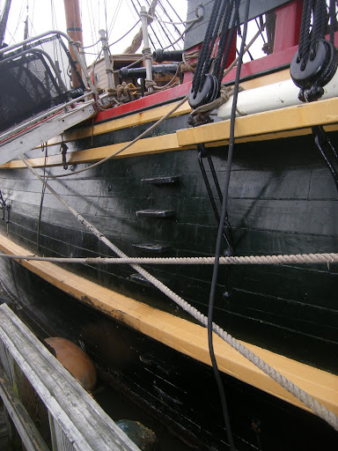

Jib
- Dread Pyrate
- Member

- 1,076 posts
- Gender:Male
- Location:Minneapolis, MN
- Interests:Piracy, stage combat, martial arts, reading, film, travel
Posted May 17, 2010 · Report post
Would not boarders want to climb aboard a ship at multiple points? A single set of stairs could be more easily defended by a few men. To swarm over a ship at various points would allow the pirates to take advantage of the larger crew they typically enjoyed.

MarkG
- Pyrate Captain
- Member

- 587 posts
- Location:Ohio
Posted May 17, 2010 · Report post
On 5/17/2010 at 3:11 PM, Jib said:
Would not boarders want to climb aboard a ship at multiple points? A single set of stairs could be more easily defended by a few men. To swarm over a ship at various points would allow the pirates to take advantage of the larger crew they typically enjoyed.
You would be surprised. During his Indian campaign the Duke of Wellington (who was still Aurthur Wellesley) took a city with only two seige ladders.
Mark

Coastie04
- Dread Pyrate
- 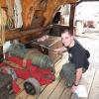
- Member

- 1,008 posts
- Gender:Male
- Location:Juneau, AK
- Interests:Nautical history, sailing (especially tall ships and my own 'Sanctioned Mistress'), shooting (of all eras and calibers), and homebrewing.
Posted May 18, 2010 · Report post
Look at today's pirate boardings. They board MUCH larger ships from little, fast inflatable boats. I've heard many accounts of them using grapnels to get aboard (including one first hand tale). Plus, very few of the crews fight back. The standard proceedure today is to barricade the crew in a safe area and wait for help to arrive. Some ships will even weld the doors to the crew quarters shut from inside. Now, this was not necessarily an option back then, but remember that there is a very big difference between a merchant crew and a pirate or naval crew. The merchant crews are not generally paid to defend the ship, but just sail it. If they are out manned and out classed, then these untrained, civilian sailors would give up the ship and hope that the pirates are leniant. Blackbeard would often send captured crews back in a slow boat with only barely enough provisions to make it to shore instead of killing them. With the prospect of living to sail again, many merchant sailors would not think twice about the owners' cargo, since to them it was just another hold full of bags and barrels.
Coastie

Bright
- Plunderer
- Member

- 380 posts
- Gender:Male
- Location:South Carolina
- Interests:He has been seen most recently in the company of the Charles Town Few and rumored to be their Quarter master
Posted May 3, 2011 (edited) · Report post
Edited May 3, 2011 by Bright

William Brand
- Mercury Malefactor
- Admin

- 8,884 posts
- Gender:Male
- Location:Logan, Utah
- Interests:My name is William Pace and I live and work as a graphic designer, illustrator and photographer in Northern Utah. I'm married to the lovely Tracy Pace and we have three children. In addition to all things art, I enjoy traveling and meeting new people from every walk of life. I've always been a fan of history, theology, and of course, Pyracy.
http://www.youtube.com/watch?v=PSkt-q-HihQ
Posted May 3, 2011 · Report post
On 5/17/2010 at 3:11 PM, Jib said:
Would not boarders want to climb aboard a ship at multiple points? A single set of stairs could be more easily defended by a few men. To swarm over a ship at various points would allow the pirates to take advantage of the larger crew they typically enjoyed.
Yes. You can grab on in so many places (i.e., chainwales, headtimbers, onboard stairway, shrouds, and any hanging line or timbers damaged in the battle itself)

Jib
- Dread Pyrate
- Member

- 1,076 posts
- Gender:Male
- Location:Minneapolis, MN
- Interests:Piracy, stage combat, martial arts, reading, film, travel
Posted May 3, 2011 · Report post
My thought was that if the pirates created a "choke point" while trying to board it might allow the defenders (with a smaller crew) to hold out against them. Approaching the ship from multiple locations would not allow the defenders to all gather in one place.

Tartan Jack
- Notorious Pyrate
- Member

- 908 posts
- Location:South Carolina
- Interests:History, Scotland, Batman, Cars, and more<br />Married with 2 kids<br />
Posted May 3, 2011 (edited) · Report post
On 5/3/2011 at 11:22 AM, Bright said:
Which one in that video is Foxe?
I'm sure he's in there somewhere. Plus, they are using both "his" boats (one is actually his and one is under his care) . . . Anyone else we know in there too?
Edited May 3, 2011 by Tartan Jack

PoD
- Pyrate Captain
- Member

- 696 posts
- Gender:Male
- Location:Warrington UK
- Interests:Pirates, graphic novels, computer art, Listening to music, Going to gigs, Beer and Wine drinking, historical research, Period weaponry and Leatherwork
Posted May 3, 2011 (edited) · Report post
On 5/3/2011 at 1:33 PM, Tartan Jack said:
On 5/3/2011 at 11:22 AM, Bright said:
Which one in that video is Foxe?
I'm sure he's in there somewhere. Plus, they are using both "his" boats (one is actually his and one is under his care) . . . Anyone else we know in there too?
Foxe is the guy at the back of the long boat next to the jack sparrow impersonator wearing brown.
I'm the one right at the back/top deck trying to reload me gun in the red coat
Edited May 3, 2011 by PoD

Bos'n Cross
- Pyrate Captain
- Member

- 536 posts
- Gender:Male
- Location:Portsmouth
- Interests:many things.......
Posted May 4, 2011 · Report post
mr.fox is the one in zee trousers and brown frock coat...........PoD you look very sporting in that red coat....makes a great targ......defender lol

PoD
- Pyrate Captain
- Member

- 696 posts
- Gender:Male
- Location:Warrington UK
- Interests:Pirates, graphic novels, computer art, Listening to music, Going to gigs, Beer and Wine drinking, historical research, Period weaponry and Leatherwork
Posted May 4, 2011 · Report post
On 5/4/2011 at 1:00 PM, Bos said:
PoD you look very sporting in that red coat....makes a great targ......defender lol
so thats why they always pick me to be on the losing side

Daniel
- Pyrate Captain
- Member

- 652 posts
- Gender:Male
- Location:McLean, VA
- Interests:History, pirates, fiction, writing, writing historical fiction about pirates, jokes, games, law.
Posted May 4, 2011 · Report post
Look, no grappling hooks. Instead, the boarders use boat hooks! Obvious reasons, too: the boat hooks must be a lot easier to control, although they have a lot less range. Do we know any historical case where boarders use boat hooks?
Regarding attack from multiple entry points, I think that would obviously be desirable, but very difficult to do in practice. Coordinating the attacks to start simultaneously under fire would be very difficult. Look at what happened to Captain England and Captain La Buse when they tried to attack the Cassandra simultaneously; only England got close enough to board, and that attempt was bloodily repulsed. If you have only one ship, then you have to use boats to to provide multiple attack points, again very vulnerable under fire. The fact that the defenders sometimes shoot the attacker's oars to pieces (which also happened in the attack on the Cassandra) would make it even harder to coordinate the attacks. The only reasonable chance I can see for attacking from multiple directions is attack with two or more boats at night, with silence and complete surprise.

Fox
- Old Twillian
- Moderator

- 2,564 posts
- Gender:Male
- Location:Beautiful lush Devon, England
- Interests:Nautical history of the 16-18th centuries and living history based thereon.
Shooting pirates.
Posted May 5, 2011 · Report post
On 5/4/2011 at 5:21 PM, Daniel said:
Look, no grappling hooks. Instead, the boarders use boat hooks! Obvious reasons, too: the boat hooks must be a lot easier to control, although they have a lot less range. Do we know any historical case where boarders use boat hooks?
The really obvious reason for using boat hooks in this case is that we didn't want to go lobbing iron grappling hooks where they might damage the ship, or worse, the defenders. This was not necessarily such an issue for real boarders, but boat hooks would be a useful tool for them nonetheless. There is an account somewhere of the small boat action at the Battle of la Hogue, in which the English boats got close enough to the shore for a seaman to pull a French cavalryman out of his saddle with a boathook.
If given the task of capturing a moored ship I would most definitely opt for multiple boats at night with muffled oars.

Swashbuckler 1700
- Dread Pyrate
- Member

- 1,115 posts
- Gender:Male
- Location:Europe
- Interests:pyrates, pryvateers, naval military and other history, different books, good movies, music (a little bit), drawing, games,...
Posted January 24, 2014 (edited) · Report post
This is an old thread but.
The boarding with boats seemed to be the standard in Gaop and most of the Age of sail.
But, about side by side boarding: Pictures this time, but they are unfortunately later..
Much later than gaop (circa 1800) but these privateer sailors, it seems, are boarding larger Indiaman using their own ship's yards.
Artist is Ambroise-Louis Garneray (1783-1857) who has done a few naval action pictures and paintings. Of course he might have been mistaken about sea tactics.
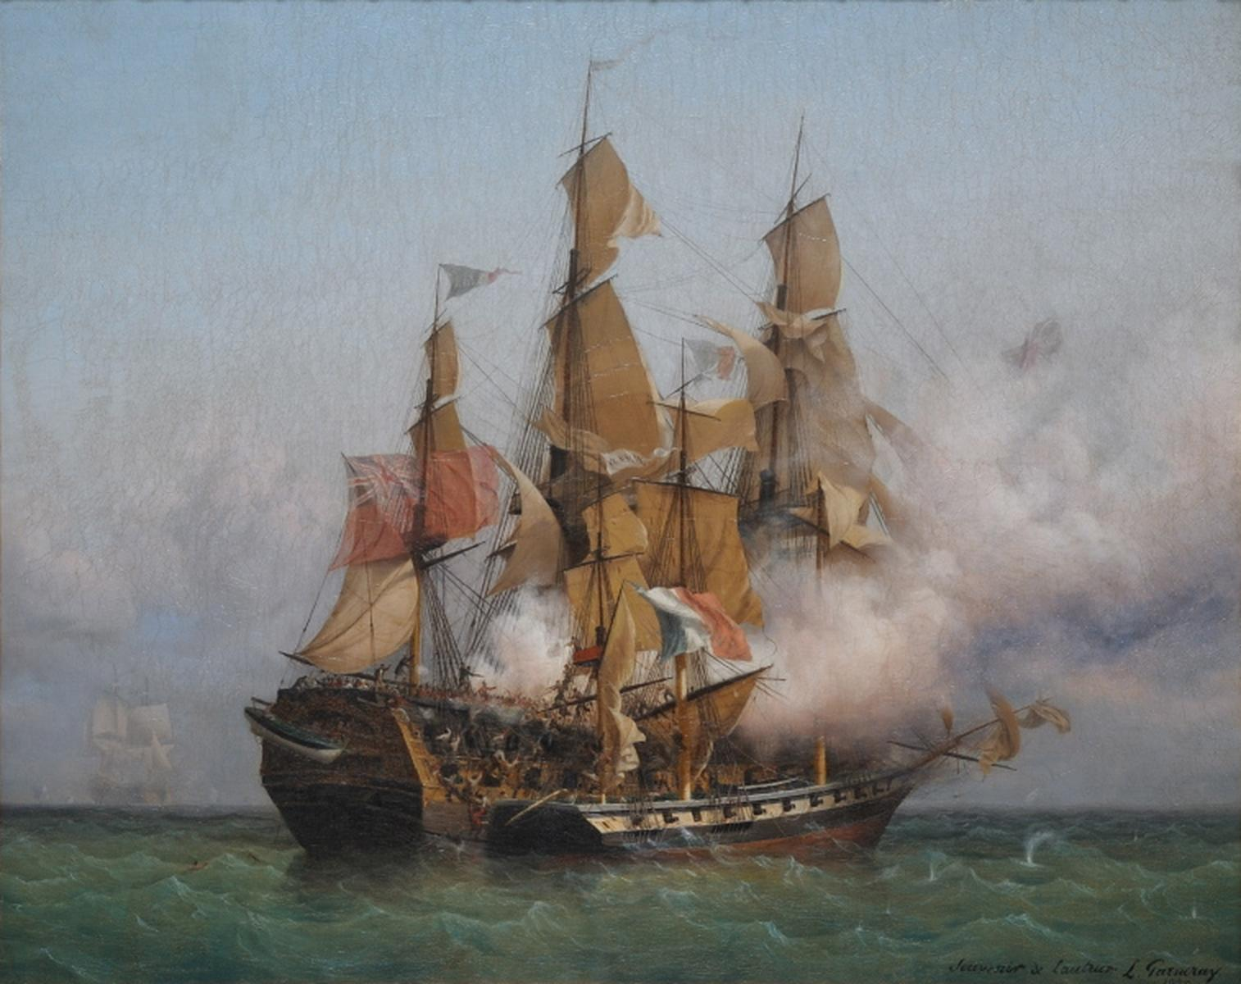
Another similar one has a pirate ship but still later
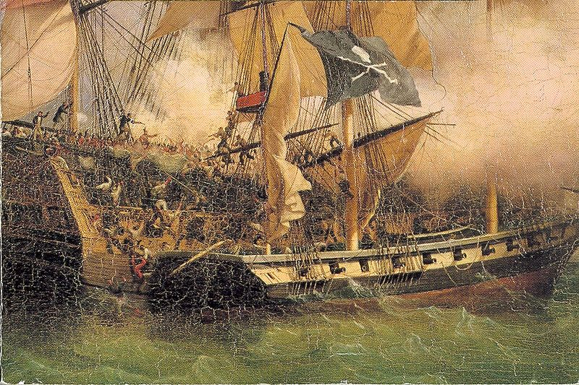
Here in this earlier 1750s painting it seems that the crew is trying to get onboard using their own bowsprit and jumping to enemy rigging.
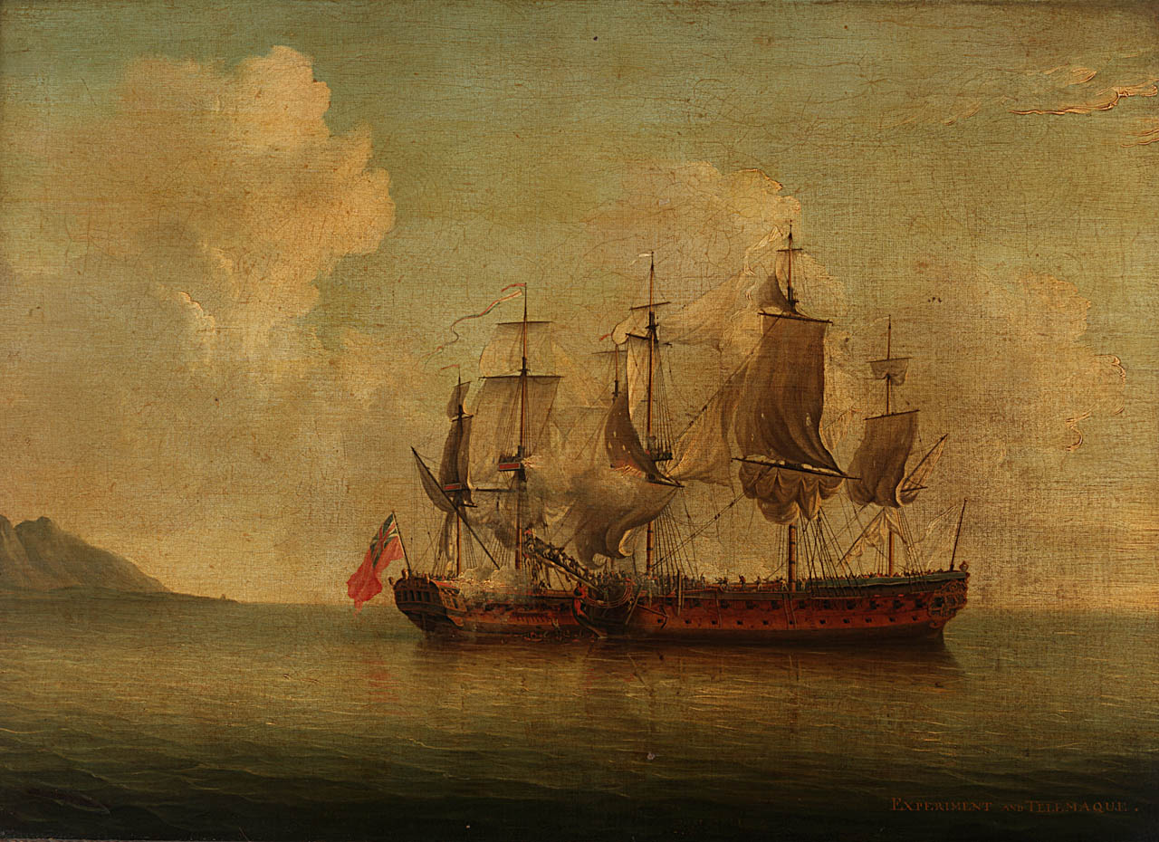
Similar tactic is pictured in not so good 19th century book Pirates Own Book.
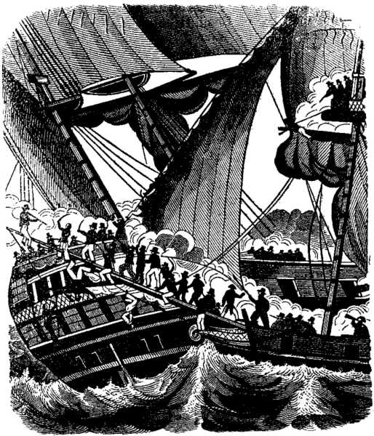
However how common these tactics were in Gaop is hard to know.
Edited January 24, 2014 by Swashbuckler 1700

Coastie04
- Dread Pyrate
- Member

- 1,008 posts
- Gender:Male
- Location:Juneau, AK
- Interests:Nautical history, sailing (especially tall ships and my own 'Sanctioned Mistress'), shooting (of all eras and calibers), and homebrewing.
Posted January 25, 2014 · Report post
First off, those first two photos are the same picture. The second one was altered to have a pirate flag and zoomed to just a portion of the original painting. I'll chime in again about one vs. multiple boarding points. If, as Foxe mentioned, there was a moored boat at night and you could use multiple boats, that would be good. However, in realistic terms, you'd board wherever you were able to. There are some benefits to boarding in one location. Coordination of the attack is much easier, once a few boarders make it to the deck, they can set up a defensive area for the rest of the boarders to swarm on with a bit more safety. Communication is easier, and it gives you a stronger force to push through lines of defenders instead of potentially being spread out too thin. Obviously, there are also some drawbacks, as swivel guns that can point inboard might be more effective to one mass group of invaders, but if it's your only or best option, then that's a risk of being a pirate. Yes, spars, rigging, and just about anything else that is available can be used for boarding. As for the boat hooks, they were a common tool of the time and would likely be used to board from a small boat. grappling hooks would possibly be used too, if available.

